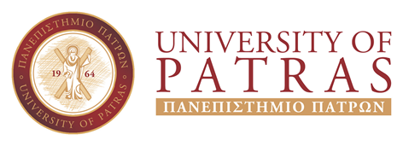 |  | 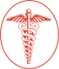  UNIVERSITY OF PATRAS  SCHOOL OF MEDICINE  http://www.med.upatras.gr

The STREAM initiative - University of Patras, School of Medicine

The STREAM (STudents for REsearch And Medicine) initiative is a an internship program which is addressed to selected undergraduate medical students from the University of Patras School of Medicine. The program aspires to provide the opportunity to experience basic research by joining research groups leaded by Greek scientists in top Medical Institutions in the USA.
The STREAM Initiative was brought together with the contribution and participation of WHBA scientists. During a pre-arranged 2 months visit the students will enroll in training activities which among others include mentorship, hands-on experimentation, lectures, panel discussions and professional development sessions designed to prepare students for their transition to US as residents or researchers. The program provides a unique opportunity to acquire the necessary experience in basic research which is a pre-requisite for all international MDs seeking resident positions in the US. In addition, the participants will have the opportunity to work in top US academic institutions and experience everyday living in the hosting US cities.

Applications for the summer of 2020 are accepted between September 01, 2019 and September 30, 2019. Students who wish to apply should send an email to the STREAM Program Coordinator Prof. Constantinos Stathopoulos (cstath@upatras.gr) or the Coordinator of the Erasmus+ Committee Assoc. Prof. George Kagadis (gkagad@gmail.com) expressing their interest to participate to the program, along with a recent CV, a motivation letter, copies of their grades, and language degrees. All communication will be in English. After the application period, eligible applicants will be invited for interview by an Ad hoc Committee with the participation of scientists which support the STREAM Program.
Criteria for the selection of students for the STREAM Program include:

 | Criterion | Points | Comments
1 | Study level | 10 – 20 | 10 well (5-6.49)  15 very well (6.5-8.4)  20 excellent (8.4-10.0)
2 | English language level | B1 – 15  B2 – 20  C1 – 25  C2 – 30
3 | Other foreign languages knowledge | 0 – 5
4 | CV and motivation | 10 – 20
5 | Interview | 20 – 50

For more information please contact Prof. Constantinos Stathopoulos (cstath@med.upatras.gr), School of Medicine, Department of Biochemistry, Pre-clinical building 3rd floor.

